**RTAB-Map in ROS 101**

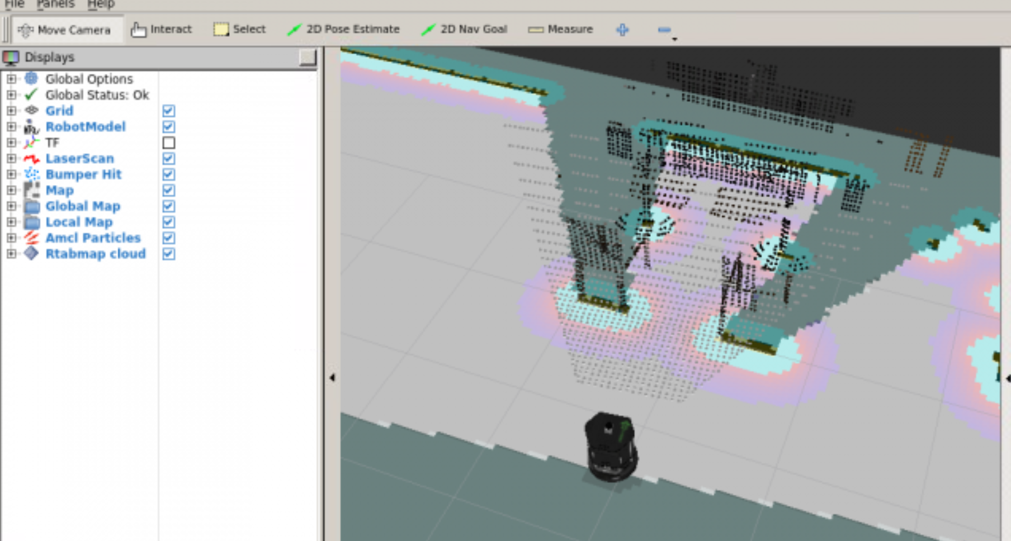

**Unit 1   Introduction to the Course**

- Summary -

Estimated time of completion: **10 min**  
  
This Unit is an introduction to the RTAB-Map ROS Micro Course. You'll a have a quick preview of the contents you are going to cover during the Course, and you will also view a practical demo.

- End of Summary -

**1.1   What is RTAB-Map?**

RTAB-Map (Real-Time Appearance-Based Mapping) is a RGB-D SLAM approach based on a loop closure detector. The loop closure detector uses a bag-of-words approach in order to determinate if a new image detected by an RGB-D sensor it is from a new location or from a location that it has been already visited. Of course, this is a very summarized explanation, you will get more details on how this loop closure detector works inside this Course. For using this approach in ROS, there exists the following package:

**rtabmap_ros**

The **rtabmap_ros** package is an implementation in ROS of the RTAB-Map approach. It basically allows us to work with the RTAB-Map approach in ROS. It has been developed by Mathieu Labbe. This is the package we will be working with during this Course.

**1.2   Do you want to have a taste?**

With the proper introductions made, it is time to actually start. And... as we always do in the Robot Ignite academy, let's start with practice! In the following example you will be testing the rtabmap_ros package with a pre-built setup, so you can have a practical look at what you can achieve with this package, which actually is what you are going to learn by completing this Micro Course. So... let's go!

Demo 1.1

a) Execute the following command in the Shell number #1 in order to launch the rtabmap_ros package.

**Execute in Shell #1**

In [ ]:

roslaunch rtabmap_ros demo_robot_mapping.launch rviz:=true rtabmapviz:=false

After a few seconds, the RViz window should automatically pop up. In case it does not, you can manually open the Graphical Tools window by clicking on the following icon in the bottom menu:

b) Execute the following command in order to stop the simulation physics:

**Execute in Shell #2**

In [ ]:

rosservice call /gazebo/pause_physics "**{}**"

d) Go to the **turtlebot_rtab** package and execute the following command in order to play the bag file and start the demo:

**Execute in Shell #3**

In [ ]:

roscd turtlebot_rtab

In [ ]:

rosbag play --clock demo_mapping.bag

After a few seconds, you will be able to visualize the 3D mapping process of an office in RViz.

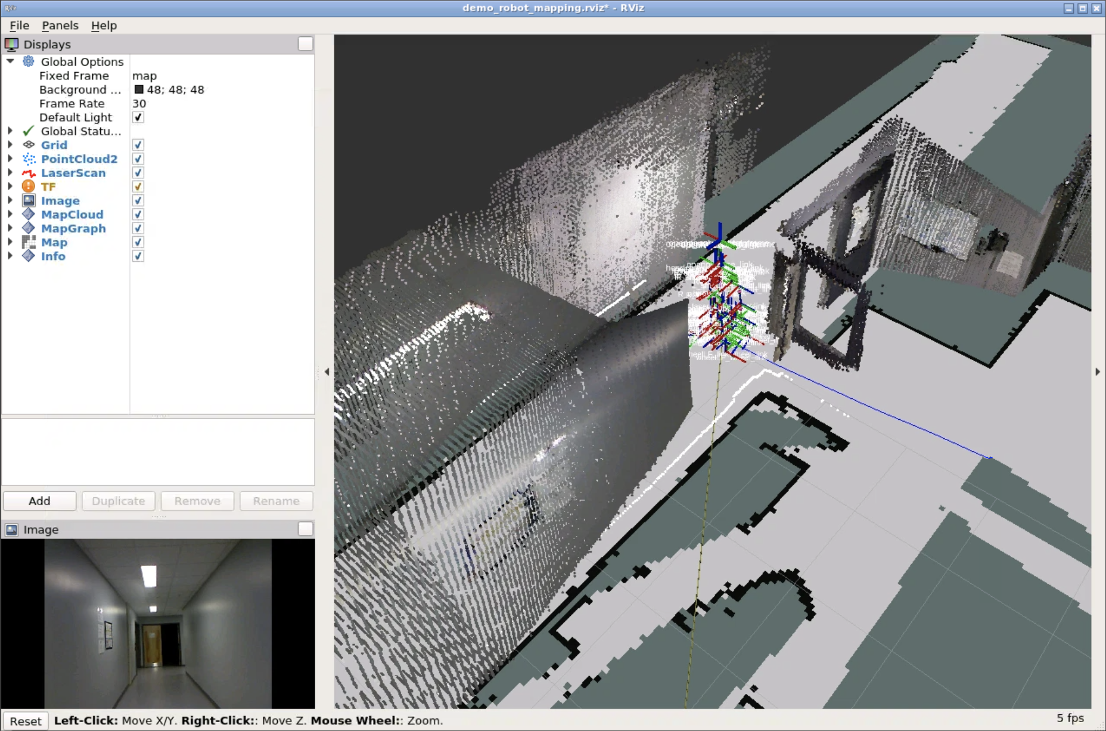

**NOTE 1**: Terminate all the programs when you finish with the demo. To terminate a program, just press Ctrl+C in the corresponding Shell.

**NOTE 2**: When you are done with the demo, don't forget to unpause the simulation physics by using the following command.

In [ ]:

rosservice call /gazebo/unpause_physics "**{}**"

**NOTE 3**: Also, when you finish with the demo, execute the following commands in order to remove a couple of parameters that have been sent and could cause conflicts during the Course.

In [ ]:

rosparam delete /rtabmap/rtabmap/depth/image_transport

In [ ]:

rosparam delete /rtabmap/rtabmap/rgb/image_transport

End of Demo 1.1

**1.3   What will you learn with this Course?**

Basically, during this Course you will adress the following topics:

* Basics of RTAB-Map.
* How to use the rtabmap_ros package.
* How does loop closure detection work internally.
* How to create a 3D Map of an environment.
* Autonomous Navigation using RGB-D SLAM.

**1.4   Minimum requirements for the Course**

In order to be able to fully understand the contents of this Course, it is highly recommended to have the following knowledge:

* Basic ROS. You can get this knowledge by following the [ROS Basics in 5 Days](https://app.theconstruct.ai/courses/55) course.

[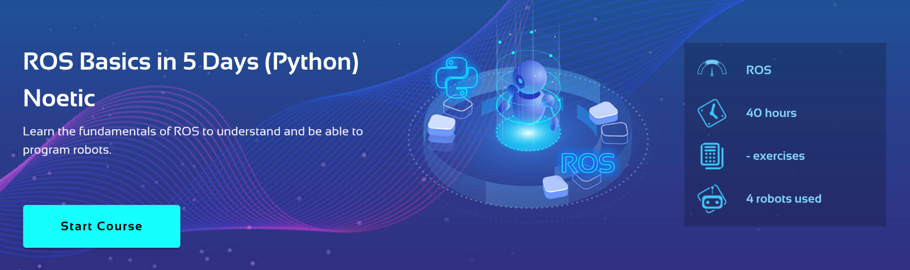](https://app.theconstruct.ai/courses/55)

* ROS Navigation Basics. You can get this knowledge by following the [ROS Navigation in 5 Days](https://app.theconstruct.ai/courses/57) course.

[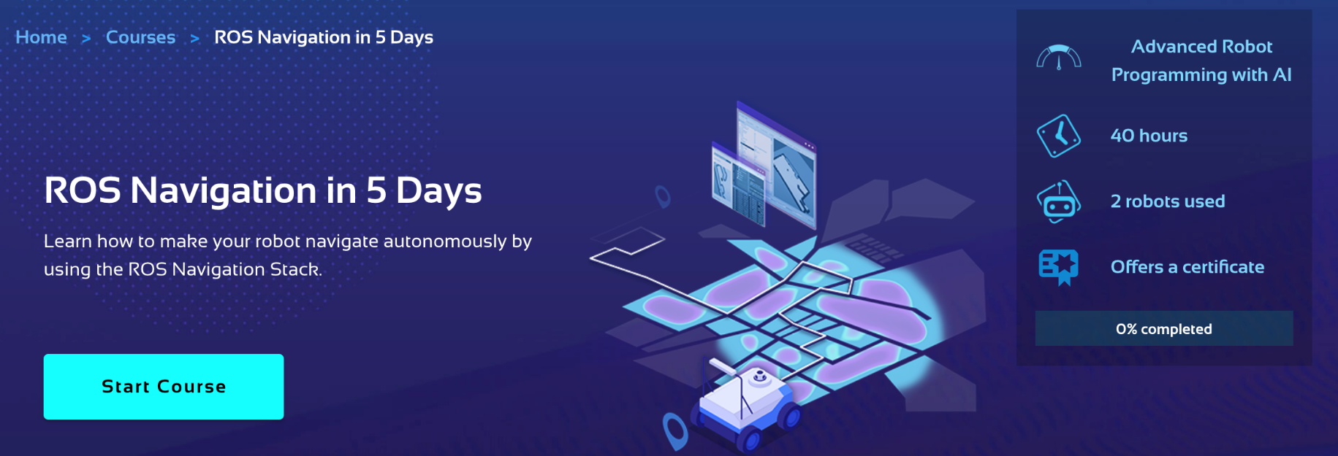](https://app.theconstruct.ai/courses/57)

**1.5   Special Thanks**

• This course wouldn't be possible without the amazing work done by the guys at IntroLab. To follow all their work, please have a look at the following links:



IntroLab Website: <https://introlab.3it.usherbrooke.ca/mediawiki-introlab/index.php/Main_Page>  
RTAB-Map: <https://introlab.3it.usherbrooke.ca/mediawiki-introlab/index.php/RTAB-Map>  
Repository: <https://github.com/introlab/rtabmap>

• And of course, we have to thank the whole ROS community for all the work done related to this package.



RTAB-Map ROS Wiki: <http://wiki.ros.org/rtabmap_ros>

**RTAB-Map in ROS 101**



**Unit 2   Basic Concepts**

- Summary -

Estimated time of completion: **1h**

This Unit is an introduction to the rtabmap_ros ROS package. This means you'll get a first contact with the package, building a knowledgebase in order to be able to understand more complex concepts.

- End of Summary -

**2.1   System Requirements**

In order to be able to use the rtabmap_ros package to perform RGB-D SLAM, you need to have, at least, a Kinect-like sensor.  
  
Anyways, the recommended robot configuration is the following:

* A 2D laser which provides **sensor_msgs/LaserScan messages**.
* Odometry (IMU, wheel encoders, ...) which provides a **nav_msgs/Odometry** message.
* A calibrated Kinect-like sensor compatible with openni_launch, openni2_launch or freenect_launch ros packages.

Two of the most common setups in order to perform RGB-D Slam are the following:

**Kinect + Odometry + 2D laser**

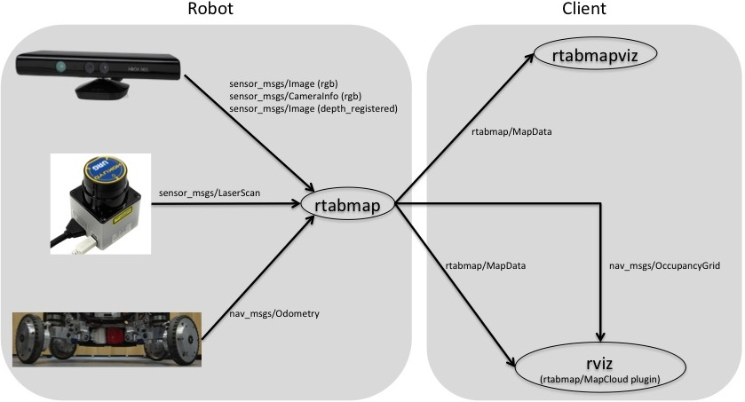

**Kinect + Odometry + Fake 2D laser from Kinect**

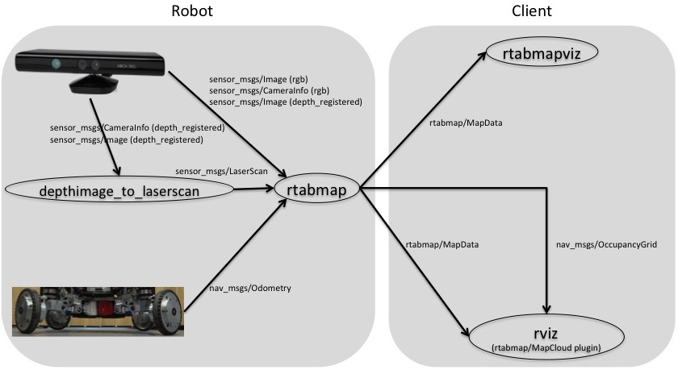

**NOTE: In the Robot Ignite Academy, you are already provided with a working system, so you don't have to worry about this. You will have to take this requirements into account if you want to use the rtabmap_ros package in a local environment.**

Exercise 2.1

a) Check that your system fulfills the requirements in order to be able to properly use the rtabmap_ros package. Identify the topics where the 2D laser, the Odometry and the 3D sensor data are being published.  
  
b) Identify which of the above setups is the one that you'll be using during this Course.

 Kinect + Odometry + 2D Laser  
 Kinect + Odometry + Fake 2D Laser

Data for Exercise 2.1

Check the following Notes in order to complete the Example:  
  
Note 1: Please don't look at the solution of this Exercise unless you get really stuck.

Expected Result for Exercise 2.1

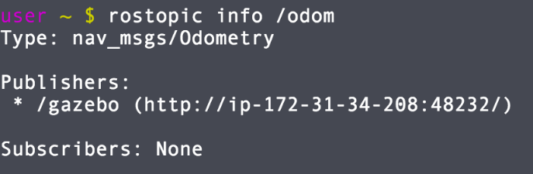

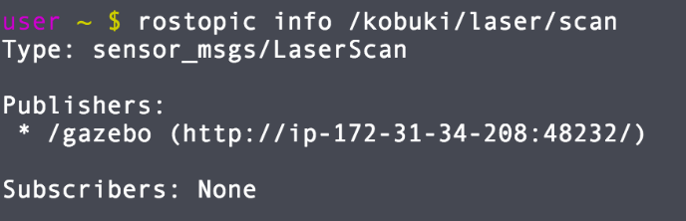

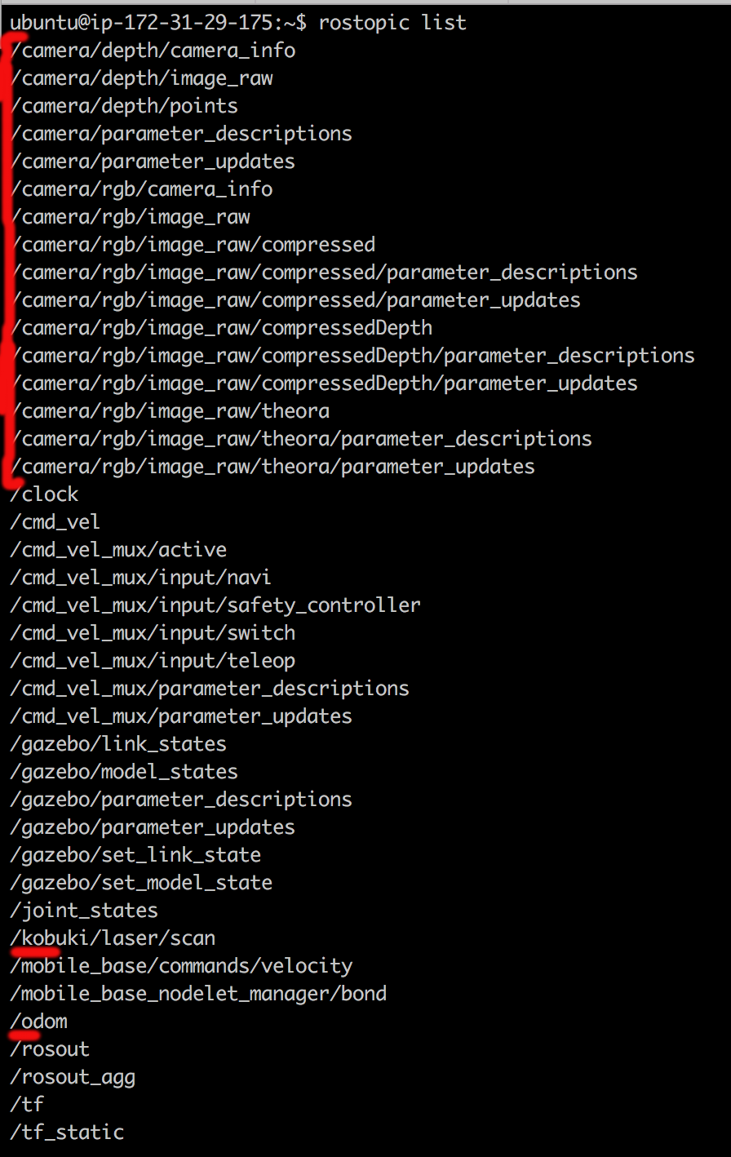

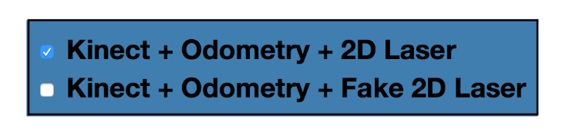

End of Exercise 2.1

**2.2   Data Visualization (RViz)**

As you already have seen, in the Ignite Academy platform we are already providing you with a complete environment in order to directly work with the rtabmap_ros package. In the previous exercise, you identified some of the topics where the different sensors are publishing their readings. But... what about visualizing this readings?

If you are already familiar with ROS, you probably will know that one of the key features that ROS provides is the **data visualization**. And if you already know this, you will also probably know that the most important tool in order to achieve this is **RViz**. In the following example, you will be visualizing the data that this simulation is providing.

Exercise 2.2

Launch RViz with the following command:

**Execute in Shell #1**

In [ ]:

rosrun rviz rviz

After a few seconds, the RViz window should automatically pop up. In case it does not, you can manually open the Graphical Tools window by clicking on the following icon in the bottom menu:

Add the necessary elements to RViz in order to visualize the following data:  
  
a) RGB Image  
  
b) Depth Cloud  
  
c) Laser Scans

Data for Exercise 2.2

Check the following Notes in order to complete the Example:  
  
Note 1: You can add the RobotModel element in order to also visualize the robot in RViz.  
Note 2: You will have to set the Fixed Frame to "base_link" in order to be able to visualize the data.  
Note 3: Visualizing depth clouds requires a lot of processing, so it may slow down your computer.

Expected Result for Exercise 2.2

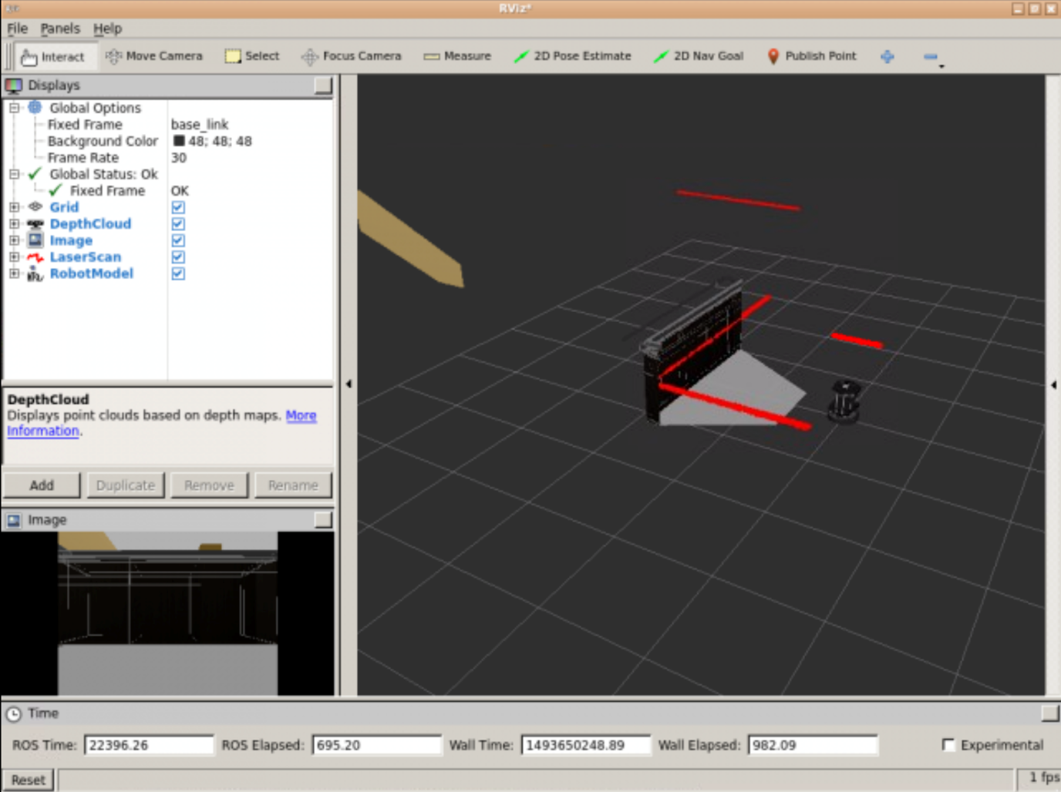

End of Exercise 2.2

**2.3   Launching RTAB-Map**

The **rtabmap_ros** package, as many other ROS packages, has a set of parameters that you need to set up in order to properly launch it. So let's analyze some of the most important ones. For that, you can have a look at the launch file named demo_launch_file.launch that is located inside the **turtlebot_rtab** package. The mentioned launch file looks like this:

In [ ]:

<launch>

<group ns="rtabmap">

<node name="rtabmap" pkg="rtabmap_ros" type="rtabmap" output="screen" args="--delete_db_on_start">

<param name="frame_id" type="string" value="base_link"/>

<param name="subscribe_depth" type="bool" value="true"/>

<param name="subscribe_scan" type="bool" value="true"/>

<remap from="odom" to="/base_controller/odom"/>

<remap from="scan" to="/base_scan"/>

<remap from="rgb/image" to="/camera/rgb/image_rect_color"/>

<remap from="depth/image" to="/camera/depth_registered/image_raw"/>

<remap from="rgb/camera_info" to="/camera/rgb/camera_info"/>

<param name="queue_size" type="int" value="10"/>

<!-- RTAB-Map's parameters -->

<param name="RGBD/NeighborLinkRefining" type="string" value="true"/>

<param name="RGBD/ProximityBySpace" type="string" value="true"/>

<param name="RGBD/AngularUpdate" type="string" value="0.1"/>

<param name="RGBD/LinearUpdate" type="string" value="0.1"/>

<param name="RGBD/OptimizeFromGraphEnd" type="string" value="false"/>

<param name="Optimizer/Slam2D" type="string" value="true"/>

<param name="Reg/Strategy" type="string" value="1"/>

<param name="Reg/Force3DoF" type="string" value="true"/>

<param name="Vis/MinInliers" type="string" value="5"/>

<param name="Vis/InlierDistance" type="string" value="0.1"/>

<param name="Rtabmap/TimeThr" type="string" value="700"/>

<param name="Mem/RehearsalSimilarity" type="string" value="0.30"/>

</node>

</group>

</launch>

Before explaining some of these parameters, you need to know this one thing: when we talk about rtabmap_ros related parameters, we need to differentiate two kind of parameters: ROS Parameters and RTAB-Map Parameters.

**ROS Parameters**

The ROS parameters are for connecting the RTAB-Map library with ROS.

* **frame_id (string, default: "base_link")**: The frame attached to the mobile base.
* **odom_frame_id (string, default: "")**: The frame attached to odometry. If empty, rtabmap will subscribe to odom topic to get odometry. If set, odometry is got from tf (in this case, a covariance of 1 is used).
* **subscribe_depth (bool, default: "true")**: Subscribe to depth image.
* **subscribe_scan (bool, default: "false")**: Subscribe to laser scan.
* **wait_for_transform (bool, default: "true")**: Wait (maximum wait_for_transform_duration sec) for transform when a tf transform is not still available.
* **wait_for_transform_duration (double, default: 0.1)**: Wait duration for wait_for_transform. To avoid some possible errors, it is recommended to set this value to "0.2".
* **database_path (string, default: "~/.ros/rtabmap.db")**: Path of the RTAB-Map's database.

**RTAB-Map Parameters**

The RTAB-Map's parameters are those related to the RTAB-Map library.

* **RGBD/NeighborLinkRefining**: Correct odometry using the input laser topic using ICP.
* **RGBD/ProximityBySpace**: Find local loop closures based on the robot position in the map. It is useful when the robot, for example, is coming back in the opposite direction. With camera facing back, global loop closures cannot be found. So using the position and previously added laser scans to the map, we find the transform using ICP. Be aware that on large-scale mapping, this method should be disabled because when the odometry is very erroneous, local ICP could give wrong results (false loop closures).
* **RGBD/AngularUpdate**: The robot should move to update the map (if not 0).
* **RGBD/LinearUpdate**: The robot should move to update the map (if not 0).
* **RGBD/OptimizeFromGraphEnd**: Here we optimized from the latest node added to the map instead of the first. By optimizing from the last, the last pose keeps it's value and all the previous poses are corrected according to it (so /odom and /map will always match together). By optimizing from the first, all the successive nodes are corrected according to the first one (so there will be a transformation between /odom and /map to correct the last pose added). However, by optimizing from the first: when some nodes are transferred, the first referential of the local map may change, resulting in momentary changes in robot/map position (which are annoying in teleoperation).
* **Optimizer/Slam2D**: Do 2D graph optimization (only optimize x, y and yaw values).
* **Reg/Strategy**: We chose ICP to refine global loop closures found with ICP using the laser scans.
* **Reg/Force3DoF**: Force 3DoF registration: roll, pitch and z won't be estimated.
* **Vis/MinInliers**: Minimum visual words inliers (after RANSAC transformation between images of a loop closure) to accept the transformation.
* **Vis/InlierDistance**: From the RANSAC transformation computed, the maximum distance of the visual word inliers.
* **Rtabmap/TimeThr**: The maximum time allowed for map update. When this threshold is reached, some nodes are transferred in the Long-Term Memory to satisfy real-time constraints. The map will be published without these nodes (until retrieved from Long-Term Memory to Working Memory).
* **Mem/RehearsalSimilarity**: In the papers, it is referred as the Weight Update threshold. If consecutive nodes have similar images (over this threshold), they are merged together, increasing the total weight of the merged node. The weighting mechanism is used for the memory management approach (less weighted nodes will be transferred first to Long-Term Memory).

**NOTE: Since this is just a Micro Course, we won't be analyzing these parameters in detail. You can have a complete look at all the RTAB-Map parameters here:** http://wiki.ros.org/rtabmap_ros

Exercise 2.3

a) Create a new package named **my_rtab_package**.

b) Inside this package, create a launch file named **start_rtab.launch** and add all the necessary parameters.

Data for Exercise 2.3

Check the following Notes in order to complete the Example:  
  
Note 1: If you don't know what parameters you need to set, just copy the ones that are being used in the example demo_launch_file.launch.

End of Exercise 2.3

**Subscribed Topics**

In order to work properly, the *rtabmap_ros* package needs to subscribe to some topics to get the data it needs. This topics are the following:

* **rgb/image (sensor_msgs/Image)**: RGB/Mono image. Should be rectified when subscribe_depth is true.
* **rgb/camera_info (sensor_msgs/CameraInfo)**: RGB camera metadata.
* **depth/image (sensor_msgs/Image)**: Registered depth image. Required if parameter subscribe_depth is true.
* **scan (sensor_msgs/LaserScan)**: Laser scan stream. Required if parameter subscribe_scan is true.
* **odom (nav_msgs/Odometry)**: Odometry stream. Required if parameters subscribe_depth or subscribe_stereo are true and odom_frame_id is not set.

Note that in each system, the name of these topics may vary. This makes (almost always) mandatory to do **remappings** from this topics to the ones that are actually providing this data in our system. You can see how this is done within the previously shown launch file.  
  
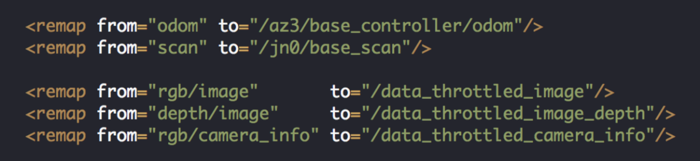

Exercise 2.4

Add to the launch file the necessary remappings in order to connect the rtabmap_ros package with the specific topics of this simulation.

End of Exercise 2.4

**Arguments**

You can also specify the following arguments to the rtabmap_ros package:

* **"--delete_db_on_start"**: Delete the database before starting, otherwise the previous mapping session is loaded.
* **"--udebug"**: Show RTAB-Map's debug/info/warning/error logs.
* **"--uinfo"**: Show RTAB-Map's info/warning/error logs.
* **"--params"**: Show RTAB-Map's parameters related to this node and exit.
* **"--params-all"**: Show all RTAB-Map's parameters and exit.

Exercise 2.5

Complete the **start_rtab.launch** launch file and execute it.

**Execute in Shell #1**

In [ ]:

roslaunch my_rtab_package start_rtab.launch

The final output should look something like this:

Expected Result for Exercise 2.5

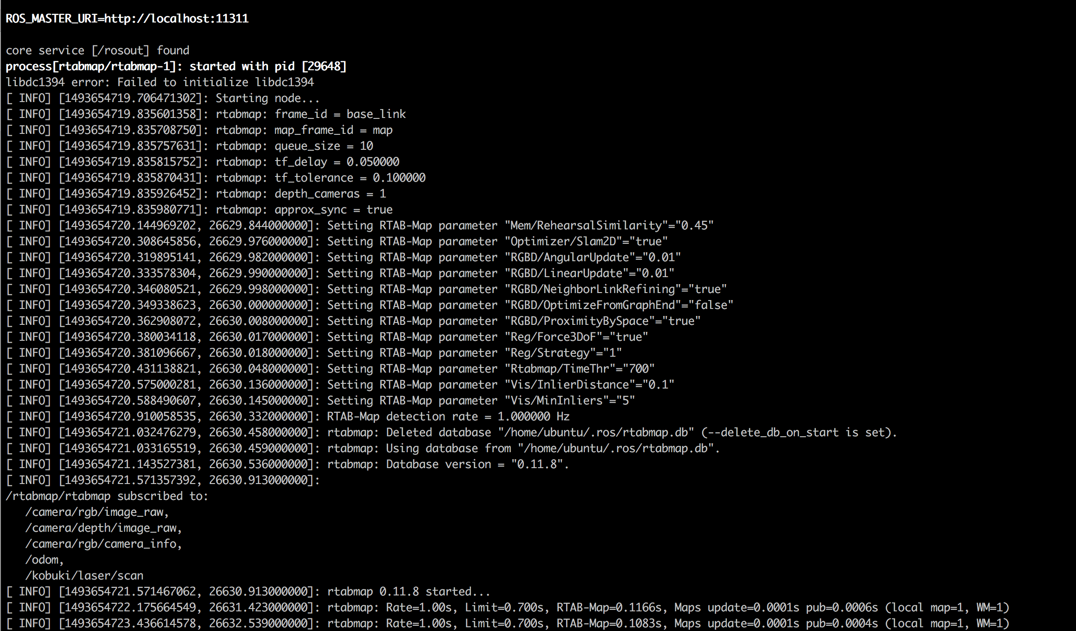

End of Exercise 2.5

Solution for Exercise 2.5

**NOTE: Please, do not look at this until you get really stuck.**

Complete example launch file:

**start_rtab.launch**

In [ ]:

<launch>

<group ns="rtabmap">

<node name="rtabmap" pkg="rtabmap_ros" type="rtabmap" output="screen" args="--delete_db_on_start">

<param name="frame_id" type="string" value="base_link"/>

<param name="subscribe_depth" type="bool" value="true"/>

<param name="subscribe_scan" type="bool" value="true"/>

<remap from="odom" to="/odom"/>

<remap from="scan" to="/kobuki/laser/scan"/>

<remap from="rgb/image" to="/camera/rgb/image_raw"/>

<remap from="depth/image" to="/camera/depth/image_raw"/>

<remap from="rgb/camera_info" to="/camera/rgb/camera_info"/>

<!-- RTAB-Map's parameters -->

<param name="RGBD/NeighborLinkRefining" type="string" value="true"/>

<param name="RGBD/ProximityBySpace" type="string" value="true"/>

<param name="RGBD/AngularUpdate" type="string" value="0.01"/>

<param name="RGBD/LinearUpdate" type="string" value="0.01"/>

<param name="RGBD/OptimizeFromGraphEnd" type="string" value="false"/>

<param name="Optimizer/Slam2D" type="string" value="true"/>

<param name="Reg/Strategy" type="string" value="1"/>

<param name="Reg/Force3DoF" type="string" value="true"/>

<param name="Vis/MinInliers" type="string" value="5"/>

<param name="Vis/InlierDistance" type="string" value="0.1"/>

<param name="Rtabmap/TimeThr" type="string" value="700"/>

<param name="Mem/RehearsalSimilarity" type="string" value="0.45"/>

</node>

</group>

</launch>

End of Solution

**So... what now?**

At this point, you have managed to successfully launch the **rtabmap_ros** package. But you still have not given it a use. In the next unit, you will use this **rtabmap_ros** package to create a 3D map of an environment, and to autonomously navigate the robot within this environment.

**RTAB-Map in ROS 101**



**Unit 3   Autonomous Navigation with RTAB-Map**

- Summary -

Estimated time of completion: **1h**

This Chapter will show how to create a 3D representation of an environment, and how to perform Autonomous Navigation using the rtabmap_ros package.

- End of Summary -

Simultaneous Localization and Mapping (**SLAM**) is the name that defines the robotic problem of **building a map of an unknown environment while simoultaneously keeping track of the robot's location in the map that is being built**. As you may already know, in ROS Navigation you use the slam_gmapping package in order to solve this problem. The slam_gmapping package is based on the OpenSLAM implementation, which uses a laser scanner in order to build a 2D map of the environment, and a particle filter in order to be able to localize the robot in the environment. Great, but... was does this have to do with the current Course?  
  
Well, not much actually, because within this Unit, we will be using a completely different SLAM approach. But I just wanted to refresh a little bit some of the knowledge you may already have about SLAM.  
  
The rtabmap_ros package uses an **RGB-D SLAM** approach based on a global **loop closure detector**. And... what does this mean? That's a great question! But... before explaining how this actually works, let's first go for a Mapping session.

**3.1   Mapping Mode**

So, now that you have already seen how to properly launch the rabmap_ros package, it is time to give it some use!! And the first thing we are going to do is to generate a Map of the environment. So... let's go! For that, you'll need to create a new launch file in order to launch both RTAB-Map and the Navigation system.  
  
For building this new launch file, you should take these 3 things into account:

1. Regarding the Navigation System, you will just need to launch the *move_base* node, since the SLAM process will be handled by the *rtabmap_ros* package itself.

1. By default, the rtabmap_ros package publishes the grid map that it's created into a */grid_map* topic. In the Navigation system, though, the grid map is read from the */map topic*. So, you'll need to do the propper remap here.

Exercise 3.1

a) Update the **start_rtab.launch** file so that it properly launches the rtabmap_ros package alongside with the navigation system. To launch the navigation system, you can include the **move_base_rtab.launch.xml** file from the **turtlebot_navigation** package in your launch file.

b) Launch the **start_rtab.launch** file and check that everything goes OK.

**Execute in Shell #1**

In [ ]:

roslaunch my_rtab_package start_rtab.launch

c) Execute the following command in order to be able to visualize the mapping process with RViz.

**Execute in Shell #2**

In [ ]:

roslaunch rtabmap_ros demo_turtlebot_rviz.launch

If everything is OK, you should see the RViz window pop up after some seconds with something similar to this:

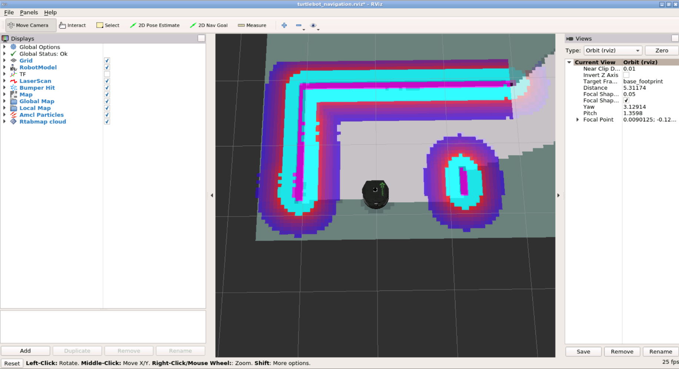

d) Move the robot around the environment in order to generate a complete map. To teleoperate the robot, use the following command:

**Execute in Shell #3**

In [ ]:

roslaunch turtlebot_teleop keyboard_teleop.launch

The complete map should look something like this:

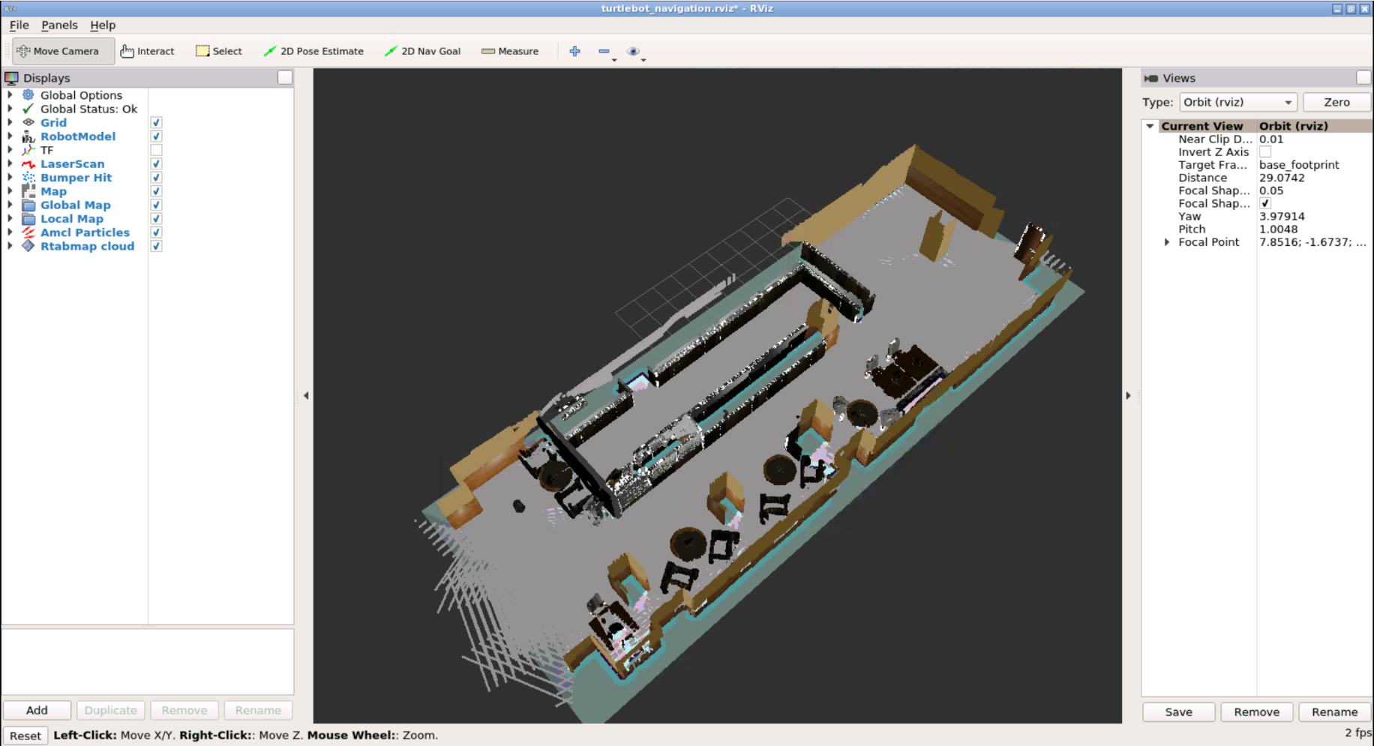

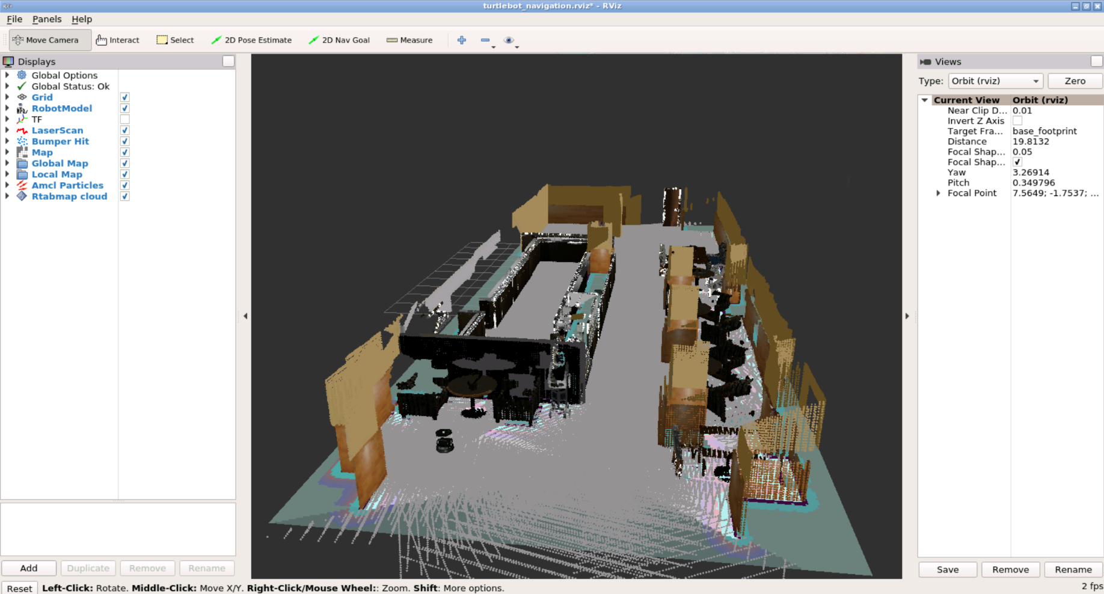

End of Exercise 3.1

Solution for Exercise 3.1

**NOTE: Please, do not look at this until you get really stuck.**

Complete Launch File:

**start_rtab.launch**

In [ ]:

<launch>

<arg name="database_path" default="rtabmap.db"/>

<arg name="args" default=""/>

<arg name="wait_for_transform" default="0.2"/>

<!-- Navigation stuff (move_base) -->

<include file="$(find turtlebot_navigation)/launch/includes/move_base_rtab.launch.xml"/>

<!-- Mapping -->

<group ns="rtabmap">

<node name="rtabmap" pkg="rtabmap_ros" type="rtabmap" output="screen" args="$(arg args)">

<param name="database_path" type="string" value="$(arg database_path)"/>

<param name="frame_id" type="string" value="base_footprint"/>

<param name="odom_frame_id" type="string" value="odom"/>

<param name="wait_for_transform_duration" type="double" value="$(arg wait_for_transform)"/>

<param name="subscribe_depth" type="bool" value="true"/>

<param name="subscribe_scan" type="bool" value="true"/>

<!-- inputs -->

<remap from="scan" to="/kobuki/laser/scan"/>

<remap from="rgb/image" to="/camera/rgb/image_raw"/>

<remap from="depth/image" to="/camera/depth/image_raw"/>

<remap from="rgb/camera_info" to="/camera/rgb/camera_info"/>

<!-- output -->

<remap from="grid_map" to="/map"/>

<!-- RTAB-Map's parameters: **do** "rosrun rtabmap rtabmap (double-dash)params" to see the list of available parameters. -->

<param name="RGBD/ProximityBySpace" type="string" value="true"/>

<param name="RGBD/OptimizeFromGraphEnd" type="string" value="false"/>

<param name="Kp/MaxDepth" type="string" value="4.0"/>

<param name="Reg/Strategy" type="string" value="1"/>

<param name="Icp/CoprrespondenceRatio" type="string" value="0.3"/>

<param name="Vis/MinInliers" type="string" value="5"/>

<param name="Vis/InlierDistance" type="string" value="0.1"/>

<param name="RGBD/AngularUpdate" type="string" value="0.1"/>

<param name="RGBD/LinearUpdate" type="string" value="0.1"/>

<param name="Rtabmap/TimeThr" type="string" value="700"/>

<param name="Mem/RehearsalSimilarity" type="string" value="0.30"/>

<param name="Optimizer/Slam2D" type="string" value="true"/>

<param name="Reg/Force3DoF" type="string" value="true"/>

</node>

</group>

</launch>

End Solution

After a mapping session as above, a database is saved here ~/.ros/rtabmap.db. Into this database, the rtabmap_ros package stores, for instance, images from the mapping session that will be later used for **detecting loop closures**.

In order to better explain how this works, let's access to this database. The rtabmap_ros package offers a tool that allows us to visualize the content of this database: the **RTAB-Map's Database Viewer**. You can open this tool using the following command:

**Execute in Shell #1**

In [ ]:

rtabmap-databaseViewer ~/.ros/rtabmap.db

You will then see something like this:  
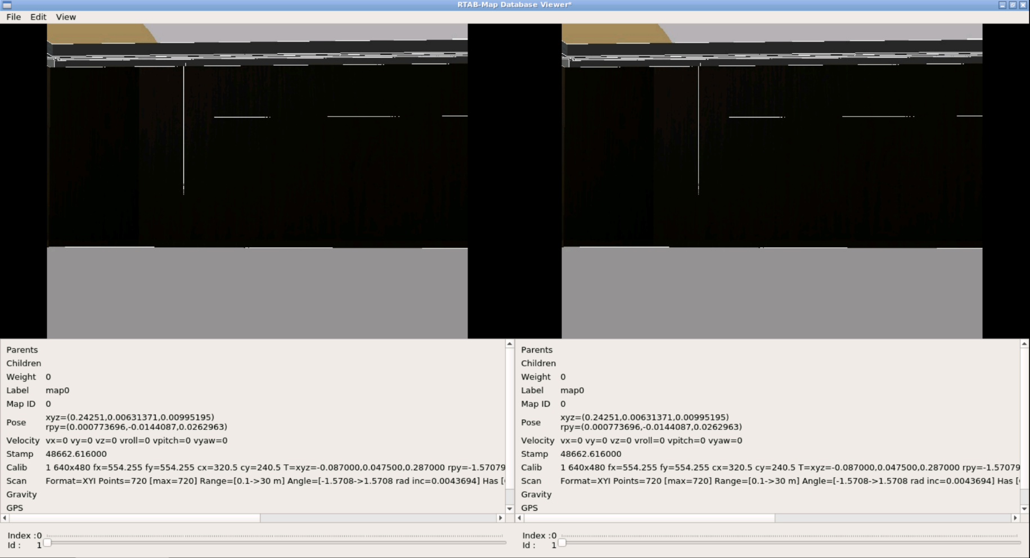

- Important Note -

Make sure to maximize the RTAB-Map Database Viewer window in order to visualize the Id sliders!

- End of Important Note -

This images you are seeing right now are the different images that have been taken during the Mapping session. If you move the **Id** slider that appears at the bottom of the screen, you will move through all the different images that are stored in the database.

You might have noticed thaat most images have some strange yellow dots on them. What are they? Can you guess? Well, basically, **this yellow dots are marking/highlightning the key features of each image**. And... how are the key features of each image selected? That's another great question!

This visual features used by RTAB-Map are using some popular techniques from computer vision including like SIFT, SURF, BRIEF, FAST, BRISK, ORB or FREAK. Most of these algorithms look for large changes in intensity in different directions around a point in the image. If you check into the different images, you will notice that there are no yellow dots centered on the homogeneous parts of the image such as the walls or the floor. Instead, the discs are inserted into areas where there are changes in intensity such as the corners. Corner-like features tend to be stable properties of a given location and can be easily detected even under different lighting conditions or when the robot’s view is from a different angle or distance from an object.

The rtabmap_ros package records these collections of visual features in memory as the robot maps the area. At the same time, a machine learning technique known as the “bag of words model” looks for patterns in the features that can then be used to classify the various images as belonging to one location. For instance, there may be a hundred different video frames like the one shown above but from slightly different viewpoints that all contain visual features similar enough to assign to the same location.

That's awesome, right? But now... what are those turquoise dots and lines that appear in some cases? Could you find out what they mean? Can you detect in which cases they appear? I'll give you some minutes...

So what? Did you discovered anything? Well... let's solve the mystery! The **turquoise dots and lines indicate visual features that two images have in common**. For instance, if you select in the Database Viewer **two images with the same Id** (so that are the same image), there should be lots of visual features in common between both images, right?

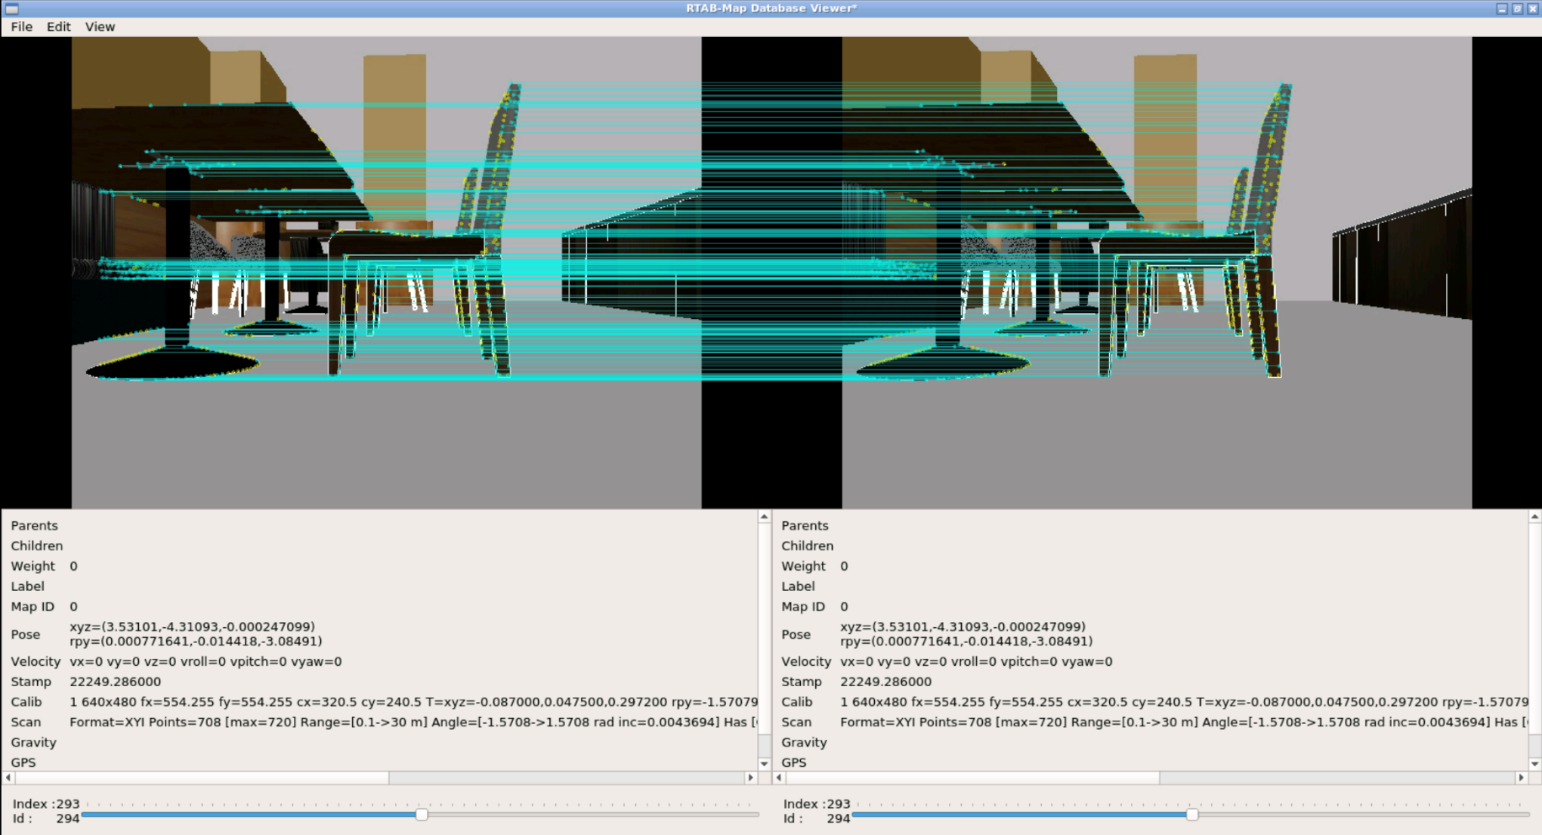

On the other hand, if we select 2 images that don't have key features in common, we won't get any matches.

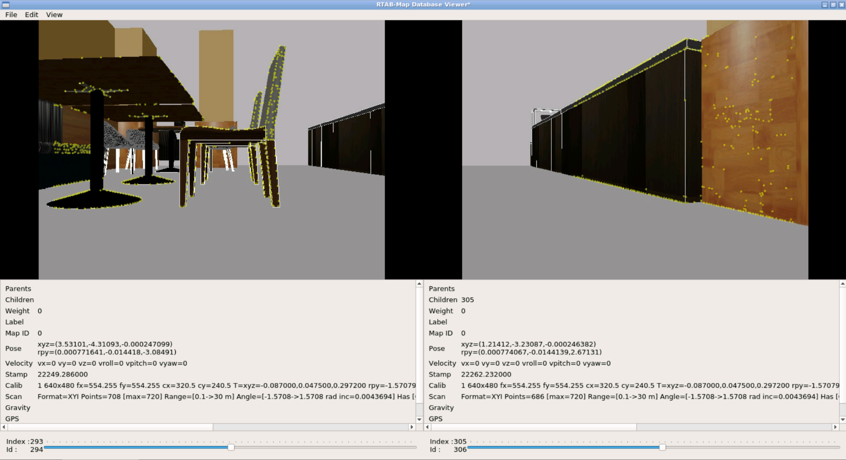

Based on the number of shared features and their geometric relations to one another, we can determine if the two views should be assigned to the same location or not. In this way, only a subset of the visual features needs to be stored in long term memory while still being able to recognize a location from many different viewpoints. As a result, RTAB-Map can map out large areas such as an entire building or an outdoor campus without requiring an excessive amount of memory storage or processing power to create or use the map.

So... what do you say? Amazing, right? Well, now you know a little bit better how the whole process works, let's move to the Localization section!

**3.2   Localization Mode**

So, after we have already mapped the environment, we can then relaunch the rtabmap_ros package within the localization mode.

In order to launch the package in localization mode, you need to take into account the following:

• The RTAB-Map Parameter *Mem/IncrementalMemory* has to be set to false, and *Mem/InitWMWithAllNodes* has to be set to true.</ul>

**NOTE: The recommended way of doing this is adding to the previous launch file the required parameters for the localization mode, and then adding a condition to them. See the following example:**

In [ ]:

<param **if**="$(arg name_of_the_argument)" name="NameOfTheParam" type="string" value="false"/>

This way, you can launch the localization mode by just adding a parameter to the launch file you've already created. Like this:

In [ ]:

roslaunch rtabmap_ros demo_turtlebot_mapping.launch localization:=true

When the localization mode is launched, you can move the robot around the environment until it can relocalize in the previous map. Then, **the 2D map would re-appear again when a loop closure is found**.

Exercise 3.2

a) Make the necessary modifications to the launch file you've created in Exercise 3.1.  
  
b) Stop the RViz session you launched in Exercise 3.1, and move the robot to a random location on the map.  
  
c) Launch the rtabmap package in Localization mode.

**Execute in Shell #1**

In [ ]:

roslaunch my_rtab_package start_rtab.launch localization:=true

d) Launch again RViz and move the robot around the environment until it relocalizes again.

**Execute in Shell #2**

In [ ]:

roslaunch rtabmap_ros demo_turtlebot_rviz.launch

Data for Exercise 3.2

Check the following Notes in order to complete the Example:  
  
Note 1: In order to be able to relocalize itself, the package must detect a loop closure. So, you should move the robot to a place where you know your database has recognizable images from.  
Note 2: When your robot localizes itself and the whole 2D map appears, if the 3D map doesn't appear, you can just click on the "Download map" option in Rtabmap cloud panel.  
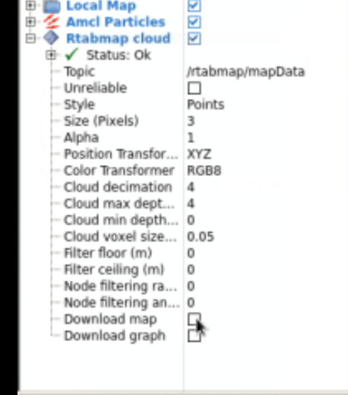

Expected Result for Exercise 3.2

Robot without localizing itself:

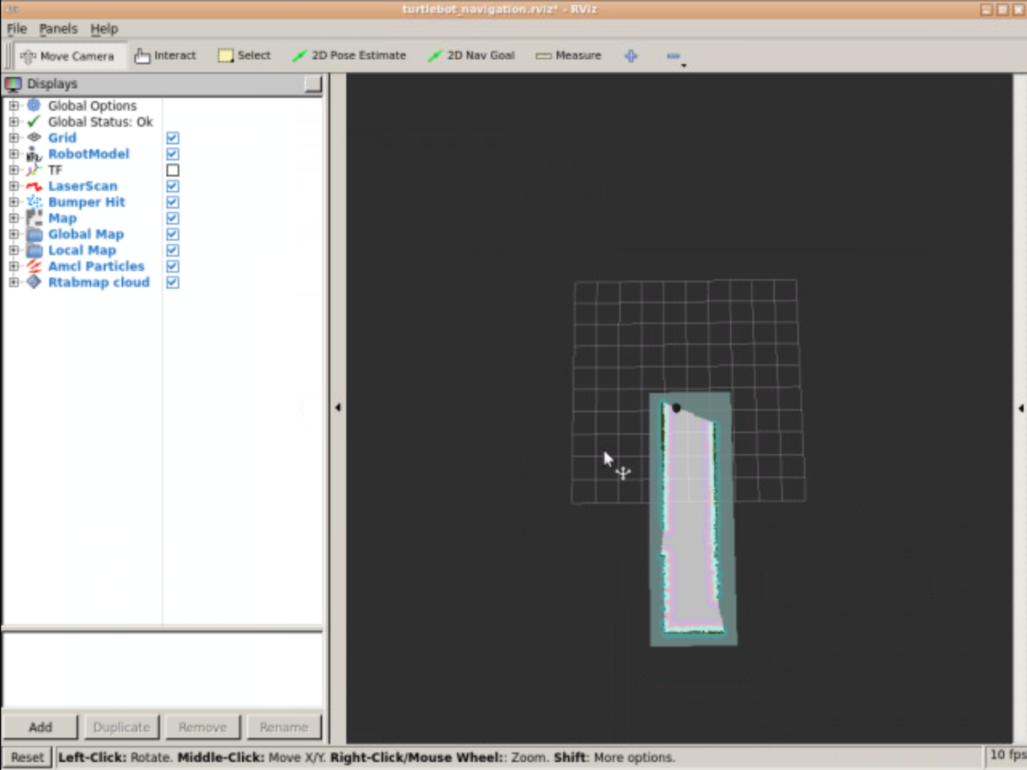

Robot localized:

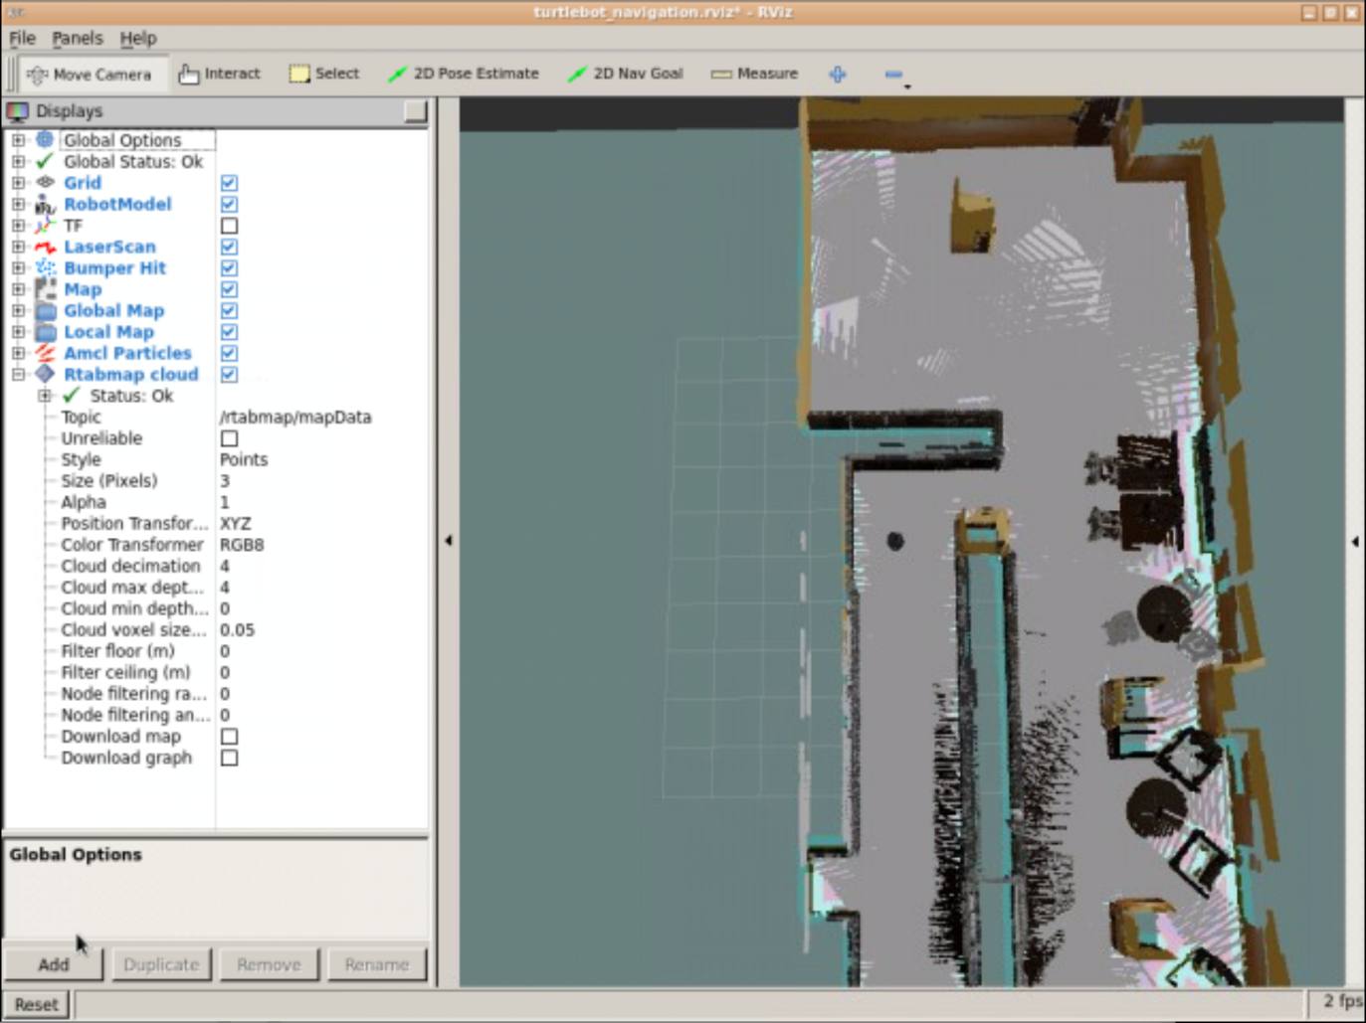

End of Exercise 3.2

Solution for Exercise 3.2

**NOTE: Please, do not look at this until you get really stuck.**

Complete Launch File:

**start_rtab.launch**

In [ ]:

<launch>

<arg name="database_path" default="rtabmap.db"/>

<arg name="localization" default="false"/>

<arg name="args" default=""/>

<arg name="wait_for_transform" default="0.2"/>

<!-- Navigation stuff (move_base) -->

<include file="$(find turtlebot_navigation)/launch/includes/move_base_rtab.launch.xml"/>

<!-- Mapping -->

<group ns="rtabmap">

<node name="rtabmap" pkg="rtabmap_ros" type="rtabmap" output="screen" args="$(arg args)">

<param name="database_path" type="string" value="$(arg database_path)"/>

<param name="frame_id" type="string" value="base_footprint"/>

<param name="odom_frame_id" type="string" value="odom"/>

<param name="wait_for_transform_duration" type="double" value="$(arg wait_for_transform)"/>

<param name="subscribe_depth" type="bool" value="true"/>

<param name="subscribe_scan" type="bool" value="true"/>

<!-- inputs -->

<remap from="scan" to="/kobuki/laser/scan"/>

<remap from="rgb/image" to="/camera/rgb/image_raw"/>

<remap from="depth/image" to="/camera/depth/image_raw"/>

<remap from="rgb/camera_info" to="/camera/rgb/camera_info"/>

<!-- output -->

<remap from="grid_map" to="/map"/>

<!-- RTAB-Map's parameters: **do** "rosrun rtabmap rtabmap (double-dash)params" to see the list of available parameters. -->

<param name="RGBD/ProximityBySpace" type="string" value="true"/>

<param name="RGBD/OptimizeFromGraphEnd" type="string" value="false"/>

<param name="Kp/MaxDepth" type="string" value="4.0"/>

<param name="Reg/Strategy" type="string" value="1"/>

<param name="Icp/CoprrespondenceRatio" type="string" value="0.3"/>

<param name="Vis/MinInliers" type="string" value="5"/>

<param name="Vis/InlierDistance" type="string" value="0.1"/>

<param name="RGBD/AngularUpdate" type="string" value="0.1"/>

<param name="RGBD/LinearUpdate" type="string" value="0.1"/>

<param name="Rtabmap/TimeThr" type="string" value="700"/>

<param name="Mem/RehearsalSimilarity" type="string" value="0.30"/>

<param name="Optimizer/Slam2D" type="string" value="true"/>

<param name="Reg/Force3DoF" type="string" value="true"/>

<!-- localization mode -->

<param **if**="$(arg localization)" name="Mem/IncrementalMemory" type="string" value="false"/>

<param unless="$(arg localization)" name="Mem/IncrementalMemory" type="string" value="true"/>

<param name="Mem/InitWMWithAllNodes" type="string" value="$(arg localization)"/>

</node>

</group>

</launch>

End Solution

**3.3   Autonomous Navigation**

So now... you're ready to autonomously navigate your robot around the map!  
  
In order to make the robot move, you just need to send goals to the */move_base/goal* topic, as you would normally do when using the Navigation stack. If you want to send goals through Rviz, you just have to use the *2D Nav Goal* option as shown in the picture below:

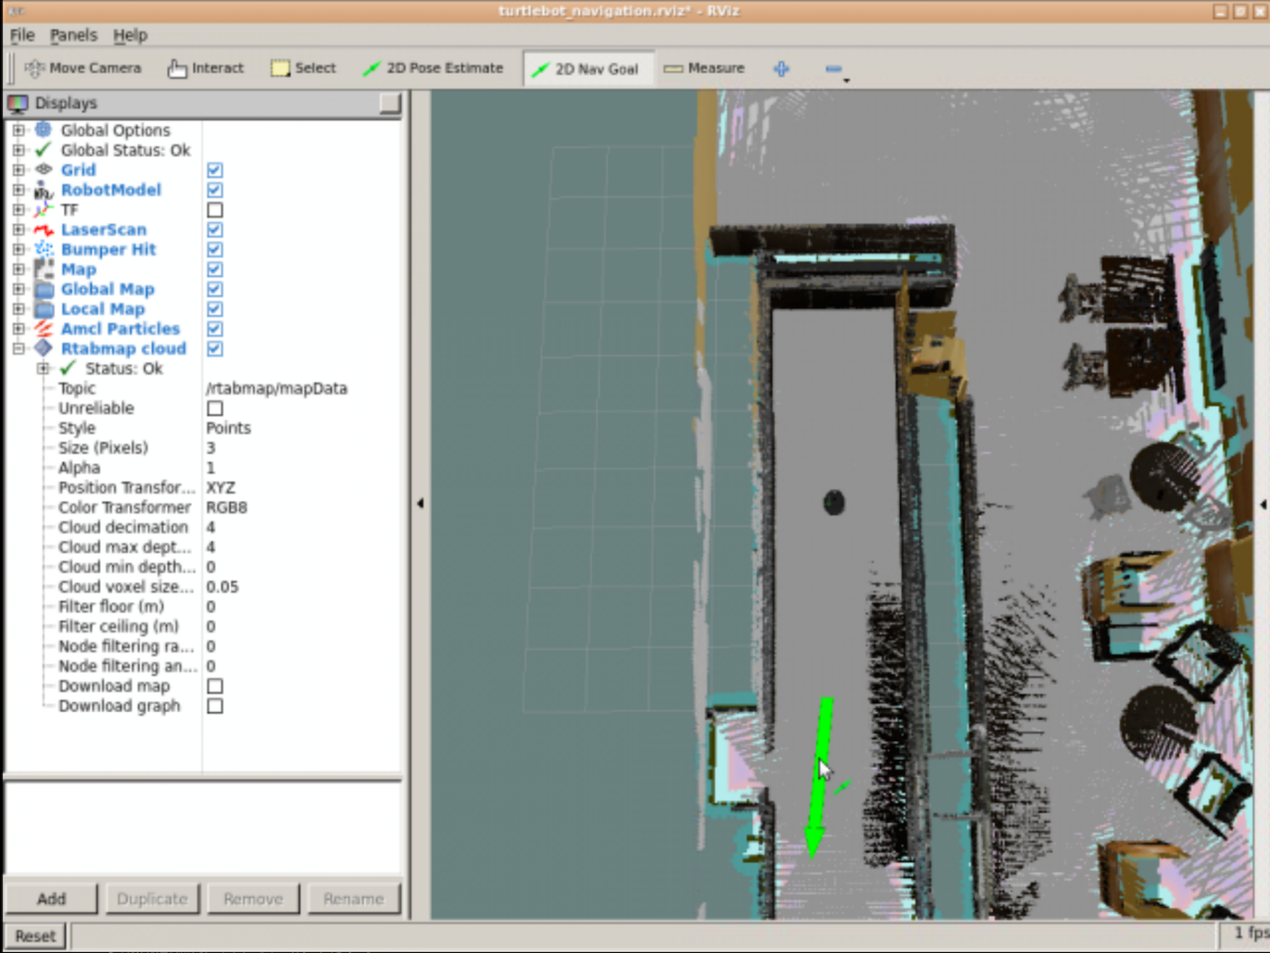

Exercise 3.3

a) Move the robot to a new random location in the map.

b) Launch the rtabmap package in Localization mode.

c) Move the robot around unitl it localizes itself, just as you did in the previous exercise.

d) Now, you're ready to start sending goals to the move_base node!

Data for Exercise 3.3

Check the following Notes in order to complete the Example:  
  
Note 1: Autonomous Navigation won't work until the robot localizes itself correctly. This means, until it finds a loop closure.  
Note 2: Make sure that you are not teleoperating the robot. If you have the keyboardte≤op.launchkeyboardte≤op.launch launched, autonomous navigation may not work.

Expected Result for Exercise 3.3

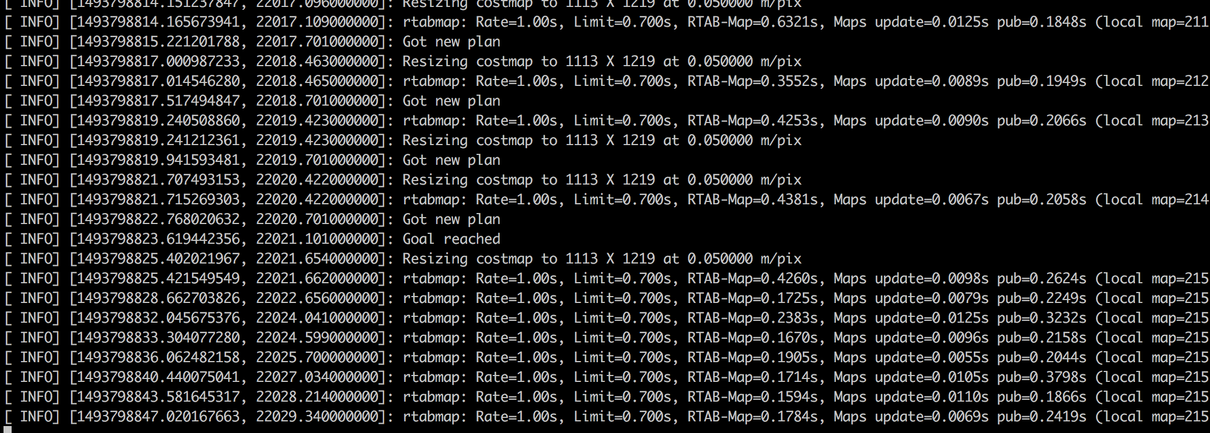

End of Exercise 3.3